Computer Language Coding Concepts

Target Command Definition in a Diagram
The concept of target command definitions is explained in the article Target Command Definition. This article only explains its expression in a diagram.

The target command definition is the last symbol in a string of class redirections and object redirections. Executions, displayed as diamond shapes, can only follow a class redirection to an inactive command displayed as a square. An inactive command, displayed as a square can only follow an object redirection to yet another square.
So there is not as much variation in object and class redirection for command symbols

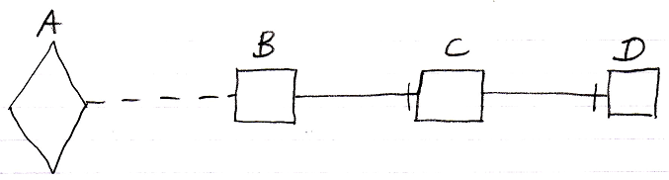

Symbol D is the command definition target of all the symbols displayed.

To keep direct conversion between a command and an object possible without any loss of structure, it is allowed to use redirections that are not really allowed, only then they will have alternative behavior and a warning will be generated. Below is a picture with wrong types of redirection.

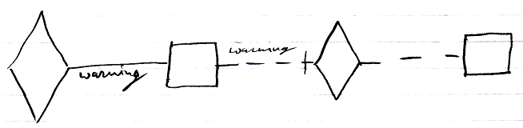

The first diamond redirects with a solid object line, which is not allowed. Automatically the object line will behave like a dashed class line, and a warning will be generated. The second symbol is a square, which redirects with a class line. This is not allowed. The class line would start behaving like an object redirection and a warning would be generated. But the square also redirects to a diamond, which a square is not allowed to do at all. The redirection will then be ignored. The connection between the third symbol and the last symbol is valid. This will make the faulty redirections behave as follows:

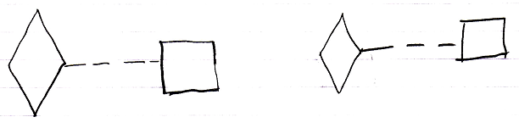

See also: Target Command Definition, Commands

Author & Copyright: Jan-Joost van Zon Date: August 10, 2008 – August 10, 2008 Location: Oosterhout, The Netherlands Status: Finished

